NAME: NAVODITAA A.R
ROLL NO: 241901071

10. EXPLORE ANTIVIRUS DETECTION TECHNIQUES
DATE: 01/04/2026
Aim:
To understand how antivirus software works and what detection techniques are used to bypass malicious file checks.
Procedure:
- Log into TryHackMe and open the Introduction to Antivirus room.
- Study the working principles of antivirus software.
- Understand detection techniques such as signature-based and heuristic analysis.
- Learn common methods used to bypass antivirus detection.
- Analyze how malicious files are identified and handled.
- Complete the tasks and answer the questions in the room.
- Review the summary and confirm completion.
Tasks:
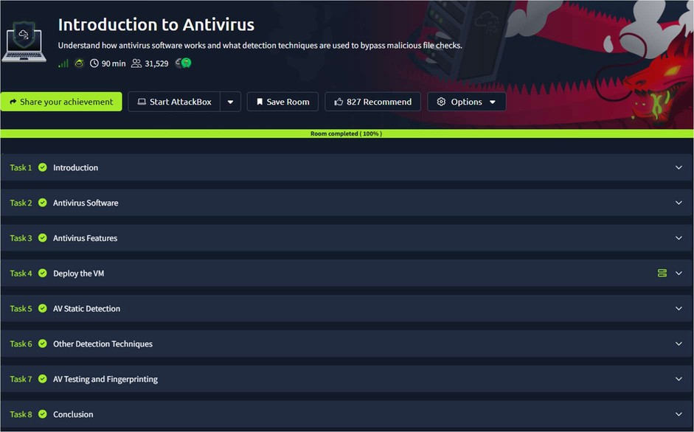
TASK 1 – Introduction

TASK 2 – Antivirus Software
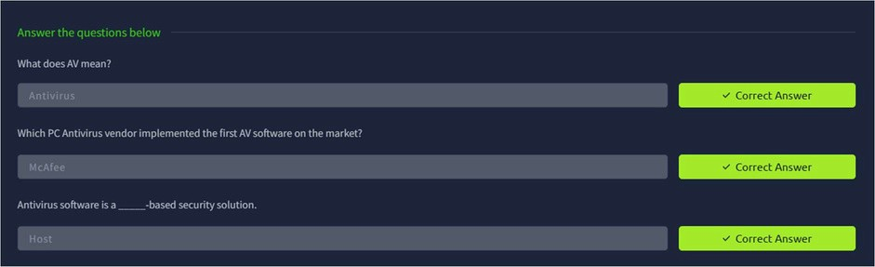
TASK 3 – Antivirus Features
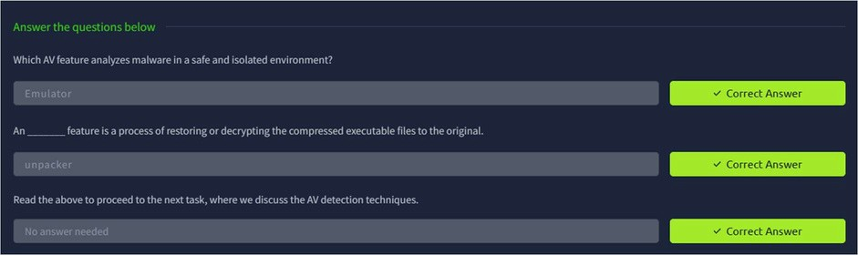
TASK 4 – Deploy The VM

TASK 5 – AV Static Detection
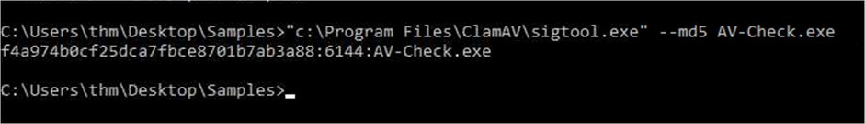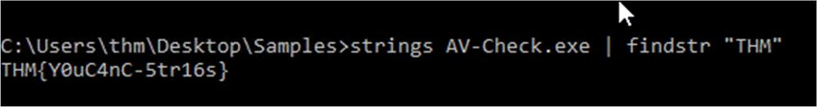
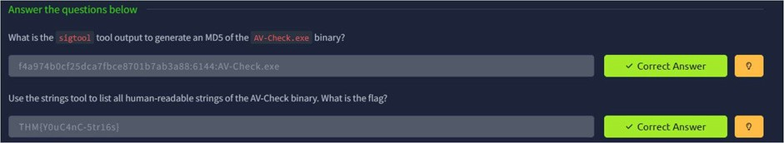
TASK 6 – Other Detection Techniques
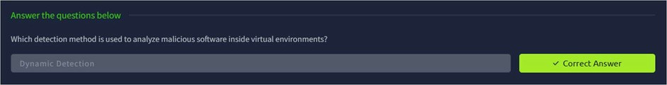
TASK 7 – AV Testing and Fingerprinting
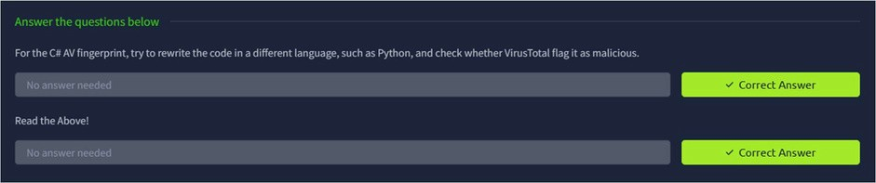
TASK 8 – Conclusion

Result:
Thus the TryHackMe room “Introduction to antivirus” was completed successfully.

